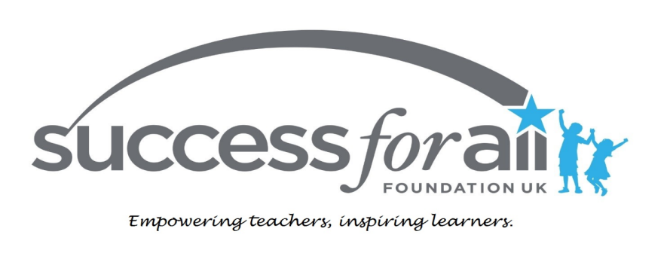

Two years of evidence- Closing the underachievement gap in reading in Welsh Primary Schools

Introduction

The issue of underachievement in British schools is well documented, with more than a fifth of children leaving Primary school without reaching a sufficient level of reading. Frequent reasons cited focus on issues associated with deprivation, which can result in children not being ready to learn when they are at school. Poor attendance and the reality that many children start school already at a lower developmental level than that expected for their age are also factors.
Where these issues occur, schools are expected to ensure that children progress faster than the standard, or expected rate. This “accelerated progress” as it is termed, is the means whereby children can catch up and close the gap between their current level of skill, and that expected for their age. This presents a significant challenge, especially when a school has a high proportion of children experiencing these difficulties.
In the academic year 2013-14, seventeen Primary Schools in Cardiff and the Rhondda Cynon Taff valleys used the Success for All programme to teach Literacy. Two previous reports (SFA 2014a, SFA 2014b) documented the accelerated progress that was achieved in these schools, with 1.86 years of standard progress achieved across years 1-6 and the impact this had on children’s attainment.
The purpose of this report is to provide further details of the impact of this continued accelerated progress on the underachievement gap.

Success for All

The Success for All (SFA) programme was developed in America at John Hopkins University and is used in over 1,000 schools throughout the USA. It has been used in English schools since 1999. Every element of the programme was developed through research into what really works in education and verified through large scale randomised control trials, providing an almost unique evidence base.
The programme uses a method of teaching, termed co-operative learning. Children are taught in ability groups, sit in teams of 4 and are actively involved in their learning, discussing and working with the members of their team. Children thoroughly enjoy SFA sessions and work hard with the expectation that they will make good progress. Schools are provided with all teaching materials and plans. SFA is simply best practice and provides a consistent approach, that schools are supported in implementing through training and regular visits by SFA consultants.
Ensuring assessments are accurate is a fundamental part of the SFA programme because children are taught in ability groups and the teaching materials provided are tightly aligned with the reading level of the children.

SFA in Wales

In 2013 SFA received a grant from the Big Lottery, administered through Realising Ambition. The aim of the project was to reduce delinquency by increasing literacy levels in children in Key Stage 2 (Years 3-6). There is a clear link between illiteracy and criminal behaviour, as 48% of UK prisoners have literacy skills below that expected of an 11 year old (Civitas, 2010).
The Central South Consortium Joint Education Service, based in Cardiff, applied to SFA to participate in this project so that they could implement SFA in local schools that had failed to respond to interventions. The first five took on the programme in January 2013, with further implementation bringing the total to nineteen and one Secondary school. The consortium provided additional funding to ensure that schools could afford to implement the programme from Nursery to Year 6.

Data Analysis

This study only looks at the fifteen schools that implemented SFA at or before September/October 2013 to facilitate a study of the impact on the gap in attainment over a second academic year.
All data was calculated using Average Point Score (APS) which provides a numerical measure of children’s progress. The expected (standard) progress is 3 APS points per academic year, (with progress exceeding 3 APS per year termed ‘accelerated’). This system enables progress to be expressed in terms of the “number of weeks of progress” achieved, which can then be compared to the standard. Details of how data was calculated is explained in Appendix 2.
It is important to note that all the comparisons between data at the beginning and end of the academic year take into account the raised expectation for attainment due to progress made during the year.

Progress data

One measure of the effectiveness of a school is the progress that children make in a year. In an ideal situation children would achieve what is termed “standard progress”. So a child who made expected (standard) progress would achieve exactly one year of progress in one academic year (36 weeks). We can term this as 100% of standard progress.
The schools chosen to participate had a history of underperformance. As a result many children did not achieve standard progress, and so fell far behind the levels expected for their age. The only way that a situation of serious underperformance can be addressed is if children make more than standard progress.
Figure 1 below shows the average percentage of standard progress in reading achieved by children in Years 1-6 across the 15 Welsh primary schools in the academic year 2013-14, academic year 2014-15 and the average over those two years. The first column represents standard progress (100%), with the second column showing that 186% of standard progress was achieved in the Welsh schools using SFA during 2013-14. This is equivalent to 1.86 years of progress in one academic year.

Figure 1
Average percentage of standard progress over 2 years
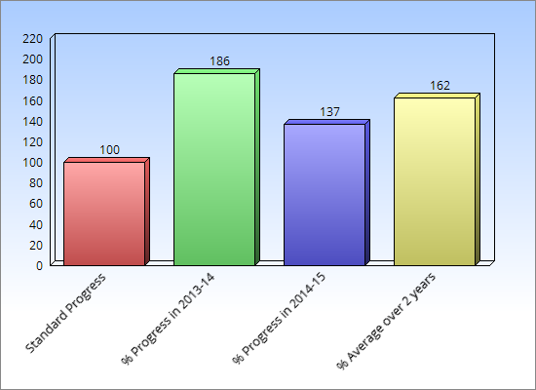

In 2014-15 the standard progress was 137% (1.37 years), with an average over the two years of 162% (1.62 years) per year. In 2014-15 the average progress was 137% (1.37 years), with an average over the two years of 162% (1.62 years) per year. Generally, schools experience the highest percentage progress in the first year of implementation because the structured, consistent approach has such an immediate impact on underachieving children. Consolidation of skills in subsequent years tends to result in progress that is not quite as spectacular however, the expectation is that it should always be significantly higher than expected. Over the two years of implementation the pupils have made almost three and a quarter years of progress.

Results – pupils at expected levels in reading – all schools

A key measure of school effectiveness is the percentage of children who have reached, or exceeded, the expected level of attainment for their age. The result of the accelerated progress achieved by the fifteen schools in our study resulted in an increase of 18.4% of children reading at age expected levels during the first year of implementation.
During the academic year 2014-15, the second year of implementation, a further increase of 8.3% of children reading at age expected levels was achieved. This equates to an increase of 26.7% more pupils over two years of implementation.
In September 2013 across all schools only 29.3% of children were at the reading level expected for their age. This is a key measure because the ability to read enables children to access to learning in all other subjects. The children in these schools were therefore highly unlikely to achieve success in any academic area. By July 2015 however, 56% were on track, demonstrating the impact of the accelerated progress achieved. This is illustrated in Figure 2 below.

Figure 2
Percentage of pupils at expected level for reading

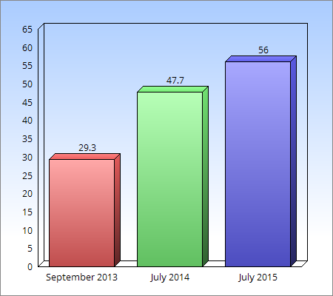

Context
This study included seven schools in Cardiff with a mobile inner city population and many children for whom English is an Additional language; and eight in Rhondda Cynon Taff (RCT) where schools are much smaller, with a legacy of deprivation due to mine closures. It is interesting to compare the impact of SFA in these two quite different contexts.

Figure 3 shows that the Cardiff schools started from a lower level than the RCT schools. However, the percentage increase in the first year was very similar, with Cardiff schools achieving a 17.8% increase and RCT schools achieving 19%. In year 2, Cardiff schools achieved an increase of 10.8% (28.6% over 2 years) and RCT schools an increase of 5.5% (24.5% over 2 years). This illustrates that SFA has had a consistent impact in schools in widely different contexts.

Figure 3
Percentage of pupils at expected level for reading

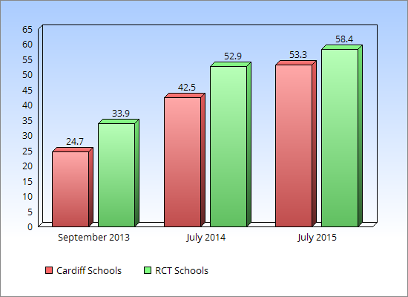

Narrowing the gap – all schools
The percentage of children at age expected level does not give a measure of whether many children are just below the expected level and or whether a large proportion of children are very significantly behind. This can be demonstrated by calculating the average number of years the children in each school are behind the expected reading level.
Results, presented in Figure 4, show that in September 2013, on average, children were 1.33 years behind the expected level in reading, but this had transformed into a gap of 0.54 years by July 2014.
By July 2015 this had further reduced to a gap of only 0.26 years – a reduction of 1.07 years or 81%.

Figure 4

Reading attainment gap in years for 15 schools
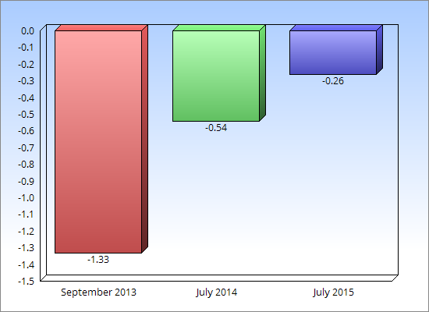

Narrowing the gap – by school
This average is, of course, a blunt tool that masks the fact that there was a wide range in the levels of achievement in schools, as can be seen in Figure 5. This shows that two schools managed to increase their reading levels so that the average exceeded that expected, while others remain behind the expected level, although all have made considerable progress in each of the two years.

In September 2013 the lowest achieving school had an average gap of 1.90 years, with the highest achieving school having an average gap of 1.03. By July 2015 the lowest school had an average gap of 0.70 years and the highest had an average 0.30 years above the expected level. This significant change in the level of underachievement can be seen in Figure 5.

Figure 5
Average reading level relative to the expected level, for 15 Welsh Primary Schools in September 2013 and July 2015
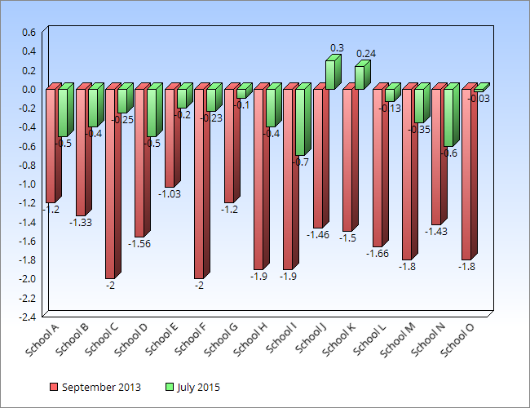

Summary and Conclusion
It is evident that many of the schools in this study still have a significant number of children who are not reading sufficiently well for their age. It is also clear, however, that the accelerated progress being achieved is having a significant impact on attainment. An average attainment gap of 1.33 years in September 2013 was transformed into a gap of just 0.26 years in July 2015.
Underachievement cannot be removed instantly but these schools are on a journey which, it is anticipated, will result eventually in every child fulfilling their potential. This can be achieved most effectively through the model which has already been established; a unified, consistent and determined approach from schools, Challenge Advisers, Consortium staff and SFA consultants working together to raise achievement.

Bibliography
http://www.civitas.org.uk/crime/factsheet-EducationinPrisons.pdf (accessed 20-2-15)

SFA (2014a) Report on Progress in Reading in Welsh Realising Ambition Schools for the Academic Year 2013/14- Internal document Success for All-UK.

SFA (2014b) Success for All - Closing the underachievement gap in reading in Welsh Primary Schools- Internal document Success for All-UK
Appendix 1
Notes on calculations and data
Average Point Score
Average Point Score and Progress Measures
What is standard progress?
The measure of standard progress is a simple method to track pupil progress against National Standards. It simply involves assigning a number (termed the Average Point Score) to a Reading Age, or to assessment or objectives as detailed below. (English National Curriculum levels, although they have been withdrawn, are still included as a general reference point)
End of Key Stage Level | English National Curriculum Level  To 2014 | Year Group Objectives  England | Reading Age | Welsh FP Outcomes | Average Point Score
 | W | Year 1 |  |  | 3
 | 1c | Year 1 | 5.11 | 4 | 7
 | 1b | Year 1 | 6.5 | 4 | 9
 | 1a | Year 1/2 | 6.11 | 5 | 11
 | 2c | Year 2 | 7.0 | 5 | 13
Welsh Foundation Phase Benchmark | 2b | Year 2 | 7.5 | 5 | 15
 | 2a | Year 3/4 | 8.0 | 6 | 17
 | 3c | Year 3/4 | 8.5 | 6 | 19
 | 3b | Year 3/4 | 9.0 | 6 | 21
 | 3a | Year 3/4 | 9.5 | 6 | 23
 | 4c | Year 5/6 | 10.0 |  | 25
KS2 Benchmark | 4b | Year 5/6 | 10.5 |  | 27
 | 4a | Year 5/6 | 11.0 |  | 29
 | 5c | Year 5/6 | 12.0 |  | 31
 | 5b | Year 6 + | 12.5 |  | 33
KS3 Benchmark | 5a | Year 6 + | 12.5+ |  | 35
Table 1 - End of Key Stage Benchmarks and equivalent APS

The expectation is that every year (36 weeks of school) the expected progress a child should make would be 3 APS. In this report this is used as a means of comparing the progress actually achieved to expected progress.
As 1 APS should be achieved every 12 weeks, the change in APS for each year group was multiplied by 12 to give an equivalent number of weeks of progress.
The extra weeks of progress achieved can be calculated by subtracting the actual number of weeks of progress achieved from 36 (the number of weeks in the academic year).
Table 2 - Expected age related Average Point Score (APS) at the beginning and end of each academic year by year group
Year group | Age expected APS beginning of the academic year | Age expected APS end of the year
1 | 9 | 12
2 | 12 | 15
3 | 15 | 18
4 | 18 | 21
5 | 21 | 24
6 | 24 | 27

Calculations for this analysis
Gap in APS in September and July- this is simply calculated by subtracting the actual average APS for a year group from the expected APS at that time. So for Year 2, September the actual APS would be subtracted from 12 and in July it would be subtracted from 15. This then measures the gain in APS over and above standard progress.
APS gap expressed as no. of weeks- this is calculated by multiplying the Gap in APS by 12 (because 1APS is equivalent to 12 weeks of standard progress).
Change in APS gap- subtracting the Gap in APS in September from the Gap in APS in July this produces the change in the APS gap. If the school has achieved accelerated progress then this will be a positive number, however if they have failed to make at least 3 APS over the year it will be negative, indicating a widening attainment gap.
Change in APS expressed as no. of weeks- this is found by multiplying the Change in the APS gap by 12 (because 1 APS is equivalent to 12 weeks of standard progress).
Change in APS expressed as % of an academic year- the change in APS expressed as no. of weeks is divided by 36 (as there are 36 weeks in an academic year) and the result is expressed as a percentage.
Change in the % of children on track- this is calculated by subtracting the % of children on track in September from the % of children on track in July.

